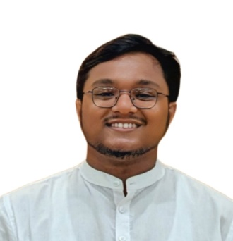**Curriculum vitae**

**Of**

**Jahid Hasan Sagor**

Akhalia, Sylhet - 3100.

Mobile: +88 01757987795

E-mail: [jahidhasansagor57@gmail.com](mailto:jahidhasansagor57@gmail.com)

**CAREER OBJECTIVES**

As a passionate undergraduate student of Geography and Environment, I am eager to contribute my analytical skills and understanding of environmental and social geography to support the mission of CARO

**PERSONAL INFORMATION**

Name : Jahid Hasan Sagor

Father’s Name : Azim Uddin

Mother’s Name : Khaleda Begum

Mailing Address :Asma Haq Tower,Varsity gate,Akhalia, Sylhet - 3100.

Permanent Address : Vill: Lourergorh , P.O: Badaghat, P.S: Tahirpur, Dist: Sunamganj.

Contact Number : +88 01757987795

Date of Birth :10 October,2001

Religion : Islam

Nationality : Bangladeshi

Marital Status : Single

**EXPERIENCE**

**Organizing Secretary**

Nritt (a dance Club at Shahjalal University of Science and Technology)

**Course Developer at Skill Arena**

(Led Content development,specializing at Uk certification course)

**EDUCATIONAL BACKGROUND**

| Degree | Board/University | Group/Major | Passing Year | Result |
| --- | --- | --- | --- | --- |
| SSC | Sylhet | Science | 2018 | 4.78 out of 5.00 |
| HSC | Sylhet | Science | 2020 | 5.00 out of 5.00 |
| BSC | Shahjalal University of Science and Technology | Geography and Environment | Running Student | 3.63 out of 4(Last Semester) |

**COMPUTER SKILLS**

* Understanding of the essential features of Microsoft Word and Excel. Having a good knowledge of how to deliver a presentation using PowerPoint.
* Georeferencing and Data Analysis With ARCGis

**LANGUAGE EFFICIENCY**

* Excellent writing and reading skills, as well as English and Bengali language fluency.

**SELF MOTIVATION & INNOVATION**

* Innovative, dynamic and self-motivated.
* Ambitious and target oriented and confident.
* Have Leadership ability as well as time sense.
* Able to work individually and in a team.
* Adaptable in every circumstance.

**INTERESTS**

* Special interest in research works in the Platform.
* Reading Journals, Magazines, Newspapers.
* To surf the Net and Traveling.
* Special interest on classical dance and Cinematography and Video Editing

**DECLARATION**

I declare that the information provided in this form are correct, true and complete to the best of my knowledge.

Regards

Jahid Hasan Sagor